**Experiment 9: Develop a program to demonstrate weather station readings using Arduino.**

**Date : 25.09.2025**

Circuit:

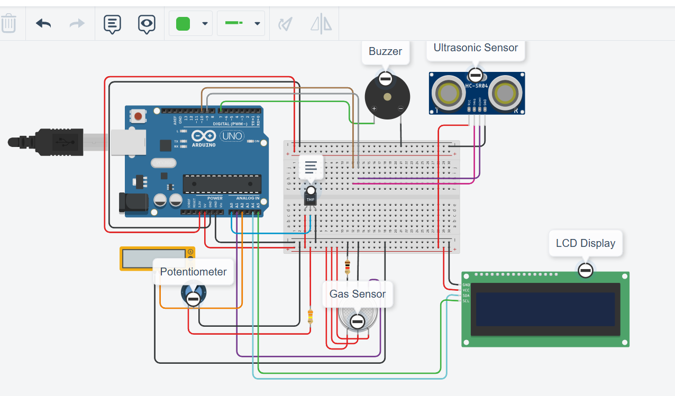

Code:

#include <Wire.h>

#include <LiquidCrystal_I2C.h> // Import the library for I2C LCD

// Sensor variables

float temp_vout, temp, voltage, rain, V_wind;

int gas_sensor_value, Windspeedint;

bool rainAlert = false, windAlert = false, tempAlert = false, gasAlert = false;

// Pin definitions

const int gas_sensor_port = A1;

const int triggerPin = 10;

const int echoPin = 9;

const int buzzerPin = 7;

const int temp_sensor_pin = A0;

const int wind_sensor_pin = A2;

// LCD initialization

LiquidCrystal_I2C lcd(0x27, 16, 2);

void setup() {

pinMode(gas_sensor_port, INPUT);

pinMode(temp_sensor_pin, INPUT);

pinMode(wind_sensor_pin, INPUT);

pinMode(triggerPin, OUTPUT);

pinMode(echoPin, INPUT);

pinMode(buzzerPin, OUTPUT);

lcd.init();

lcd.backlight();

Serial.begin(9600);

}

void loop() {

// Measure Rainfall

digitalWrite(triggerPin, LOW);

delayMicroseconds(2);

digitalWrite(triggerPin, HIGH);

delayMicroseconds(10);

digitalWrite(triggerPin, LOW);

long duration = pulseIn(echoPin, HIGH);

rain = 0.01723 * duration;

rainAlert = (rain > 100);

// Measure Wind Speed

V_wind = analogRead(wind_sensor_pin) * (5.0 / 1023.0);

Windspeedint = (V_wind - 0.4) * 20;

windAlert = (Windspeedint > 10);

// Measure Temperature

temp_vout = analogRead(temp_sensor_pin);

voltage = temp_vout * 0.0048828125;

temp = (voltage - 0.5) * 100.0;

tempAlert = (temp > 30);

// Measure Gas Level

gas_sensor_value = analogRead(gas_sensor_port);

gasAlert = (gas_sensor_value > 200);

// Prioritize and Display Alerts

if (gasAlert) {

lcd.clear();

lcd.setCursor(0, 0);

lcd.print("Gas ALERT!");

tone(buzzerPin, 1200, 2000);

delay(2000);

}

if (tempAlert) {

lcd.clear();

lcd.setCursor(0, 0);

lcd.print("Temp ALERT!");

tone(buzzerPin, 600, 2000);

delay(2000);

}

if (rainAlert) {

lcd.clear();

lcd.setCursor(0, 0);

lcd.print("Rain ALERT!");

tone(buzzerPin, 1000, 2000);

delay(2000);

}

if (windAlert) {

lcd.clear();

lcd.setCursor(0, 0);

lcd.print("Wind ALERT!");

tone(buzzerPin, 800, 2000);

delay(2000);

}

// Display Normal Readings

lcd.clear();

lcd.setCursor(0, 0);

lcd.print("Rain: "); lcd.print(rain); lcd.print("mm");

lcd.setCursor(0, 1);

lcd.print("Wind: "); lcd.print(Windspeedint); lcd.print("MPH");

delay(2000);

lcd.clear();

lcd.setCursor(0, 0);

lcd.print("Temp: "); lcd.print(temp); lcd.print("C");

lcd.setCursor(0, 1);

lcd.print("Gas: "); lcd.print(gas_sensor_value);

delay(2000);

}

Output:

